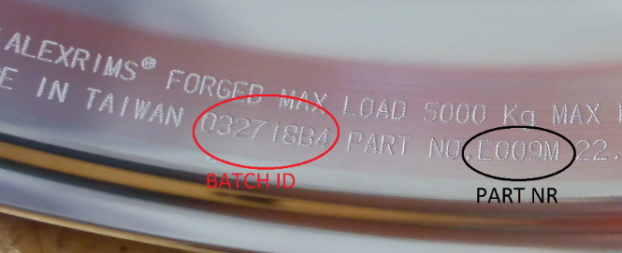
- General Wheel information
Part number*:
Finish:
Batch ID*:
Was the wheel involved in an accident?*
YES NO

Where is the wheel positioned?
not mounted (e.g. new/ stock/spare)
Truck/ Trailer*:
truck trailer other: Axle line (1st/2nd/3rd/..)*:
Left/Right*: Inside/Outside:*
Left Right Inside Outside not applicable

- Failure Of The Wheel
What is the area of examination?*
physical failure -> continue to 2.1
aesthetic failure (appearance) -> continue to 2.2
  - Which physical failure occurred? (+ specify in ‘Detailed description’ if possible)
Detailed description:
air loss drop center
air loss bead seat
air loss at valve or valve hole area
crack bolt hole to vent hole
crack bolt hole to bolt hole
crack vent hole to vent hole
deviate dimensions
other:

  - Which appearance failure occurred?

- Your Contact Details
Company name* |  | Your reference
Address 1 |  | Parts bought at*
Address 2 |  | Workshop
Postal code + city* |  | Date of replacement*
Country*
Contact person* |  | Email address

Collection Address*:
Same as above
Other:
Company name*
Address 1*
Address 2
Postal code + city*
Country*
Contact person + email address*

- Please note:
- Fields marked with * are obligatory
- Please keep the damaged part available for collection/ inspection
- Please send us following photo documentation along with your warranty request
  - Overview picture
  - Picture of the failure
  - Picture of the Batch ID and part number

